

## LA GRANDEE INTERNATIONAL COLLEGE

**Simalchaur , Pokhara Nepal**

A Project Proposal On

Aawas

**Submitted to:**

Bachelor of Computer Application (BCA) Program

In partial fulfillment of the requirements for the degree of BCA under Pokhara University

|  |  |  |  |
| --- | --- | --- | --- |
| **Name:** | **Course** | **Semester** | **P.U. Registration Number** |
| Bishwas Paudel  Mausam Pariyar | BCA  BCA | 6th  6th | 2021-01-53-0054  2021-01-53-0060 |
| Santosh Banstola | BCA | 6th | 2021-01-53-0080 |
| Sital wagle | BCA | 6th | 2021-01-53-0081 |

Date: 2024/04/26

# Table of contents

List of Figures III

1. Introduction 1

Problem Statement 2



2.

Objectives 3



3.

Methodology 4



4.

5. Project Gantt Chart 6

Deliverables 7



6.

# List of Figures

Figure 1: Process (Flow) diagram 5

Figure 2: Project Gantt chart 6

# Introduction



**Aawas** is a one stop platform for providing accommodation to students, professionals, travelers and families. This site offers a diverse option ranging from individual rooms to Apartments and Shared Rooms with cost-economic and affordable alternatives. Further, the User-Friendly Interface allows for easy navigation through smart search filters, enabling precise matching based on location, price, amenities, and accommodation types. Real-time updates ensure access to the newest availabilities, eliminating outdated options. Secure messaging facilitates direct communication between users and Landlords, streamlining enquiries and booking processes. It’ll mitigate the problem of manual searching of rooms and apartments and create ease for people to find a perfect home for their living. It includes all the real world entities of Rental Services.

Aawas is a web-based application that allows users to find the homes and rooms according to their requirement and wants. Further, it allows the landlords to advertise their vacant space to let it for renting using this site. Users can filter their wants and can get a perfect household for themselves and for their families or just a commercial space where a nice office setup can be established. Users can analyze the rate of rooms and go further as per their requirements with appropriate deals. The Motto of this site is “Secure Your Comfort Living”. This site focuses on complete transparency, convenience to the users and ease for landlords to select the appropriate candidates as the tenants for their household. The prime motive of this site is to save the valuable time of both the seekers and the renters. Just browsing through this website can provide someone a space to live in and for some to let it for rent.

# Problem Statement



In today's fast-paced world, finding a place to stay can be a big problem for students, workers, and other people. The current websites and apps for finding accommodation aren't always easy to use, not reliable and don't provide the transparent and detailed information of the space.

* + The contemporary issue regarding the renting business is that people still don’t rely on the modern approaches like websites, social media etc… as there’ve been a lot of scams and foul play in such path.
  + People go manually door to door to get a perfect space to live in which obviously a time is consuming process.
  + Further, Users often struggle to find what they're looking for among a large no of listings, and sometimes the information is old or out-of-date.
  + The landlords are also not able to advertise their vacant space which is open for renting.
  + There seems a communication and marketing gap in market regardless the landlord’s willingness to let and seekers willingness to find a room.

Because of these problems, people waste a lot of time and effort searching for a place to live, and they might end up feeling unsure about their choices. What's needed is a new platform that's easy to use and puts users' needs first. This platform should keep information up-to-date in real-time and make it easy for users to communicate with property owners. With a better system in place, people can find the perfect place to live quickly and confidently.

# Objectives



The key objective of the Aawas is:

* To save valuable time of users i.e. both seeker and renter through providing rooms according to the requirements and allowing advertisement of vacant space respectively.

For the development of Aawas Site we use the iterative model. Iterative model is one of the popular model for development of projects. Iterative model starts with a simple implementation of a subset of the software requirements and iteratively enhances the evolving versions until the full system in implemented.



**4. Methodology**

* Inside Problem Identification Phase, the main problem that we discovered is that there is a communication and marketing gap among the seekers and the landlords and further, there is not enough advertisement of vacant spaces. The willingness of landlords to let and the willingness of seekers to have a living space has not been fulfilled through existing mediums.
* During Problem analysis phase, we come to know some requirements regarding the development of the system. They are presented below:
  + To showcase different spaces with detailed information such as locations, Price, availability date etc. which create ease to user to find an optimum option.
  + To have a well-Managed database for user records.
  + To be dynamic to address certain changes in the information.
* In Requirement analysis phase, we will do feasibility analysis for the system based on the requirements mentioned above. Some of the feasibility analyses that we will do are:
  + Technical Feasibility Analysis
  + Operational Feasibility Analysis
  + Economic Feasibility Analysis
  + In the system design phase, we will use system design tools like DFD, E-R diagram, and flowchart and build a conceptual model of the system.
* After making a conceptual model, actual coding for the system will take place
* System testing and debugging is done when required.
* System Implementation takes place after the system is tested and ready to use we will provide further maintenance for improvements and updates with emergency maintenance.

## Process (Flow) Diagram

The Process or Flow diagram for the aawas as shown below.

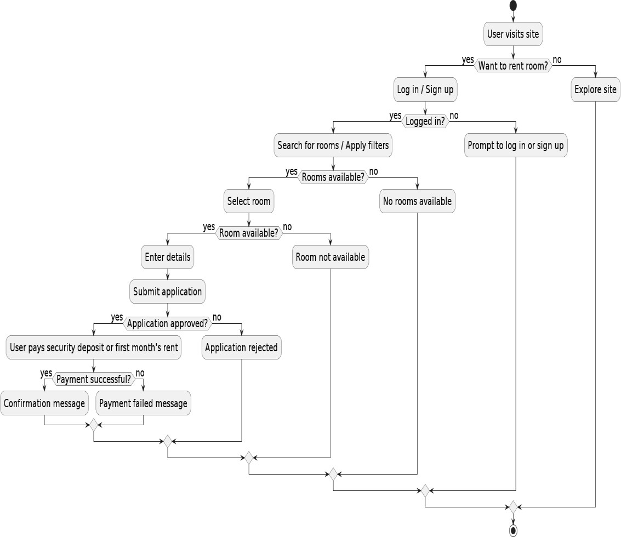

Figure 1: Process (Flow) diagram



**5. Project Gantt Chart**

|  |  |  |  |  |  |  |  |  |  |  |
| --- | --- | --- | --- | --- | --- | --- | --- | --- | --- | --- |
| Tasks | **on** | **on** |  |  |  | **Progress**  **report** |  |  |  | **Defens** |
| **Start day** | **0** | **1** | **2** | **10** | **18** | **19** | **20** | **28** | **34** | **35** |
| **End Day** | **1** | **2** | **10** | **18** | **19** | **20** | **28** | **34** | **35** | **37** |

Figure 2: Project Gantt chart



**40**

**35**

**30**

**25**

**20**

**15**

**10**

**5**

**0**

**Group Proposal Mid**

**Formati Submissi Build 1 Build 2 Review Term**

**Build 3 Build 4 Review**

**Final**

**e**

there are certain expectations to be fulfilled by it for it to be called a successful system. Even though one system can never quite fulfill all the requirements or criteria of every single employee and there are some criteria that can be lifted fulfilled.



**6. Deliverables**

After a system is created,

* + - Fully functional web application accessible on both desktop and mobile devices.
    - User-friendly interface with intuitive search filters for browsing accommodation listings.
    - Real-time updates for listings to ensure users have access to the latest available options.
    - Secure messaging feature enabling direct communication between users and property owners/managers.
    - Streamlined booking process, facilitating inquiries, negotiations, and reservations within the platform.

# 7. References

Find Properties, H. f. (n.d.). Retrieved from GharBheti: https://gharbheti.com/ Nepal, R. F. (2017, October). Retrieved from Rooms Finder Nepal:

https://roomsfindernepal.com/

Rental, P. (2020, January 15). *Want to rent flat in Pokhara?* Retrieved from Pokhara Rental: https://pokhararental.com/

Sapkota, A. (2021, September 23). Retrieved from Mero Ghar: https://[www.scribd.com/document/527006369/MeroGhar](http://www.scribd.com/document/527006369/MeroGhar)